**Travel Trax Tours**

1.INTRODUCTION

* 1. Overview
* Describe the changing function of travel agency and tour operation during the post Independence period in India;
* Discus the evolution of Travel Trax Tours operation business in India;

1.2 Purpose

A concept of rural tourism has been developed for showcasing the art, crafts and culture of rural India and for creating gainful employment in villages with tourism potential

**2.Problem Definition & Design Thinking**

2.1 Empathy map

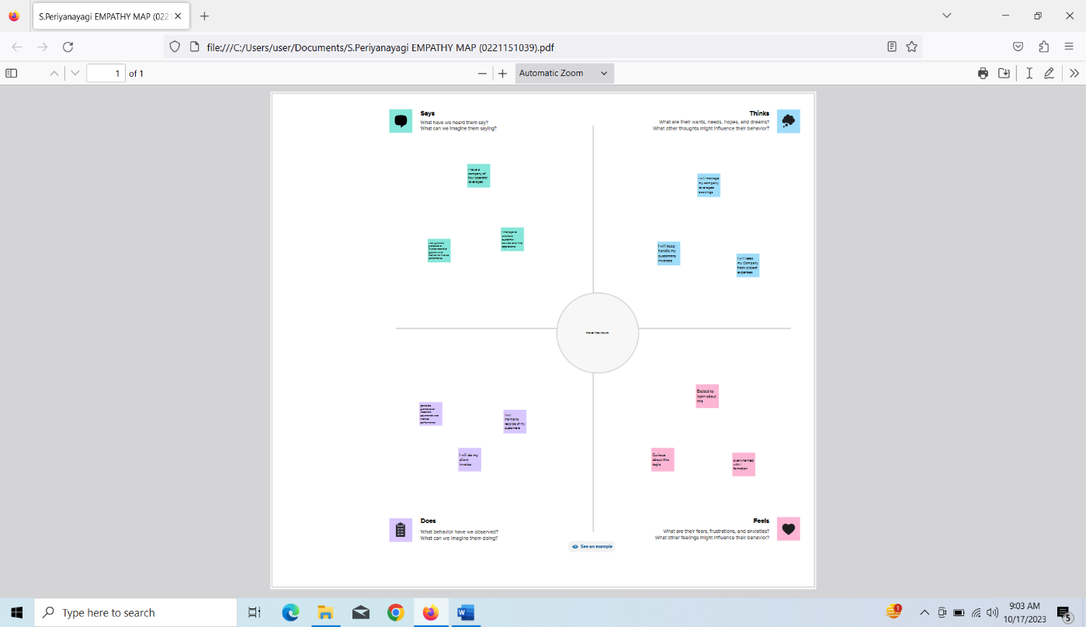

**2.2 Ideation & Brainstorming Map**

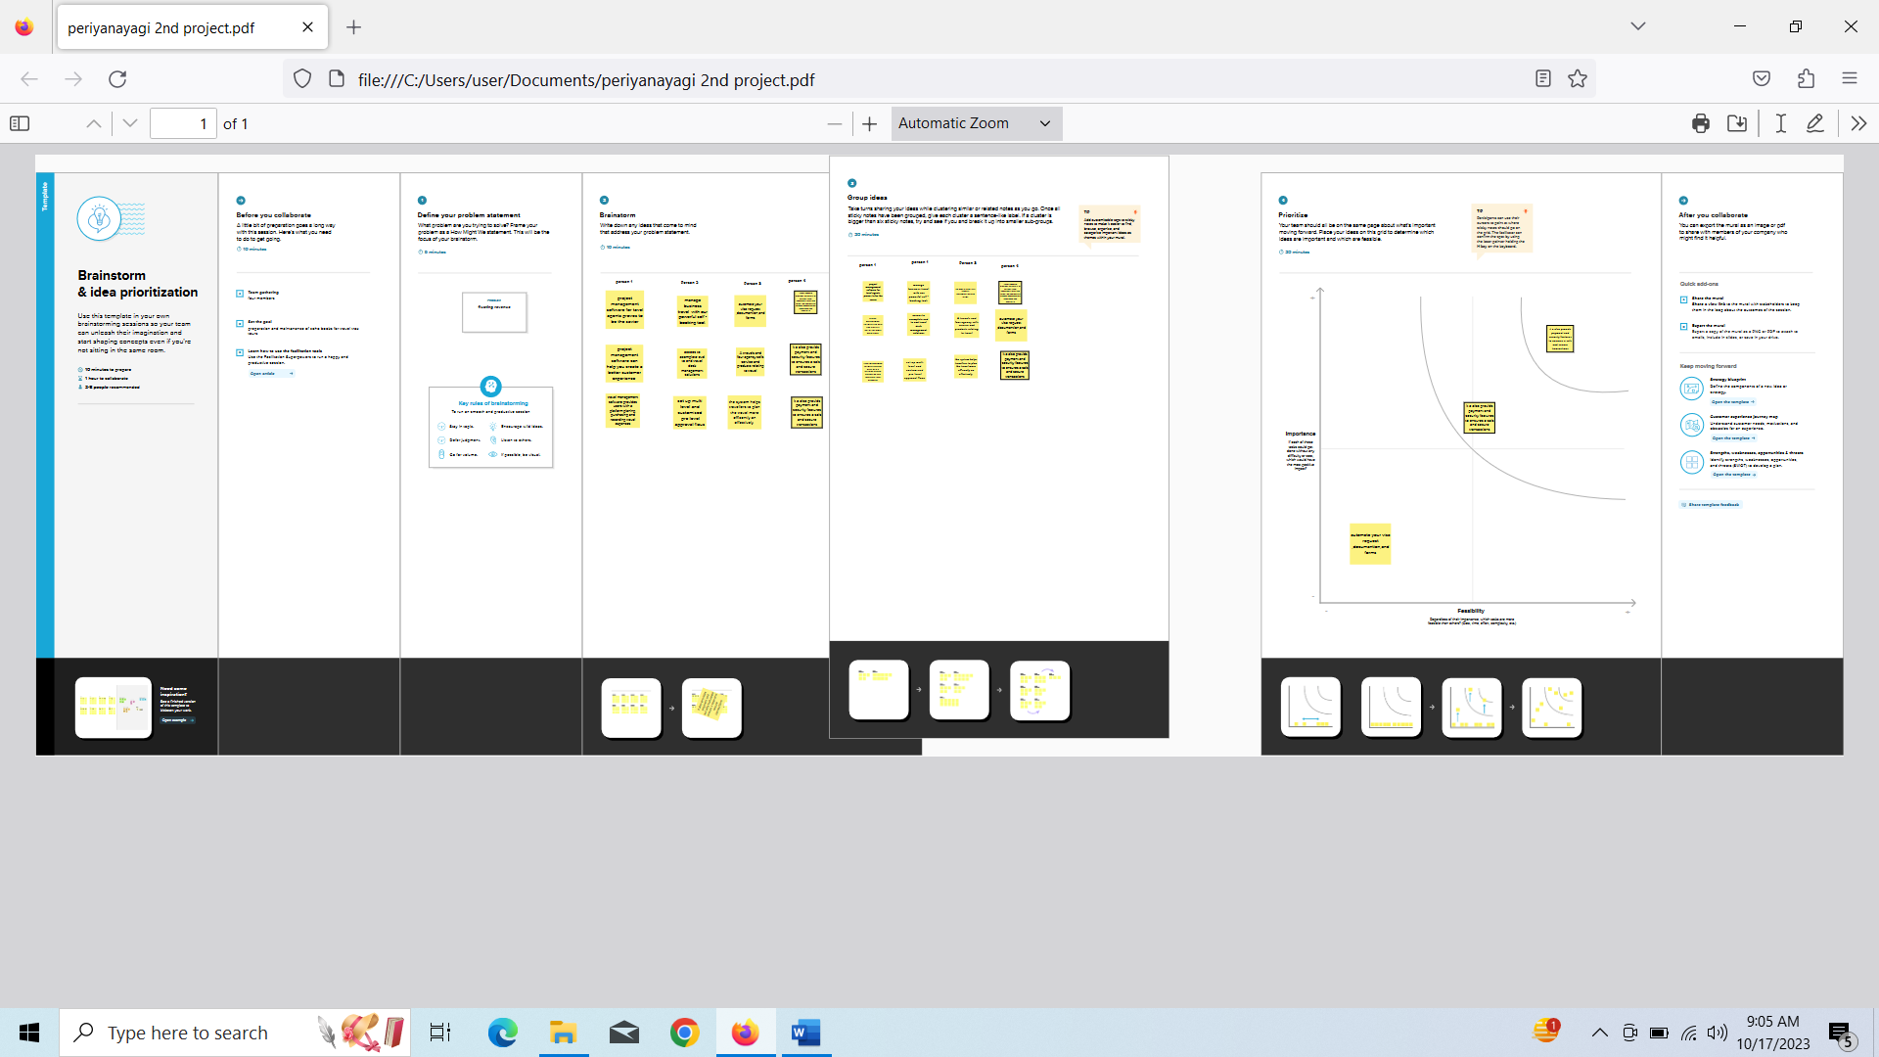

**3 Result**

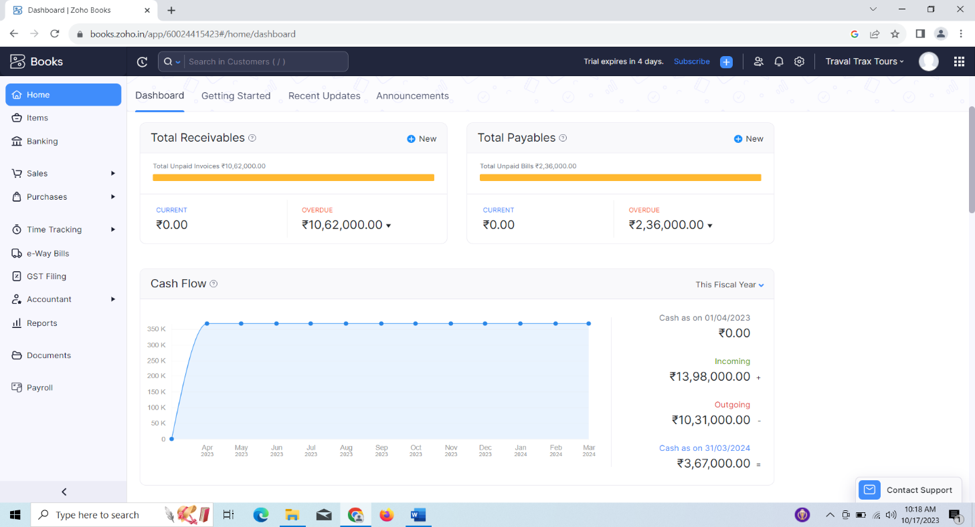

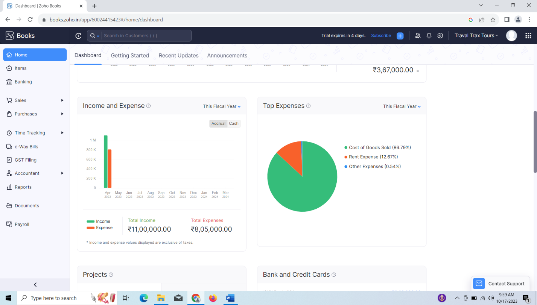

**4 Advantages and Disadvantages**

**Advantages**

* One of the more affordable option.
* Many plan option and ons.
* Robust features set.
* Ease of use.

**Disadvantages**

* Plan restriction based on user.
* No payroll services.
* Limited integration option vs. competitors.

**5 Applications**

The solution of preparing and maintaining Zoho Books is versatile and can be applied across various industries and organization. It is highly applicable to consulting firms, freelancers, e-commerce business, and service providers of all kind.

**6 Conclusion**

In conclusion, the project involving the preparation and maintenance of Zoho Books holds great promise for enhancing financial management across various sectors, including healthcare facilities like Travel Trax Tours. Its advantages in term of efficiency, accuracy, and financial reporting make it a valuable for small and medium-sized business.

**7 Future Scope**

I apologize, but still don`t have any specific information on ‘Future Scop Travel Trax Tours’ as it appears to be a niche or specific topic that is not widely documented in publicly available sources up to my last knowledge update in September 2021. If this is a recent development or a specialized tour company, I recommend searching for information on the internet or contacting the organization directly to get the most up-to-date and accurate details about their tours and offerings. If you have any specific questions or need information on a related topic, please feel free to ask, and I will do my best to assist you.